

Programming for smart contract

Project work



**Reverse a String**

**Id No : 2100030107**

**Name : Ch . Naga Prathap**

**Reverse a String smart contract using solidity**

Code and Procedure:

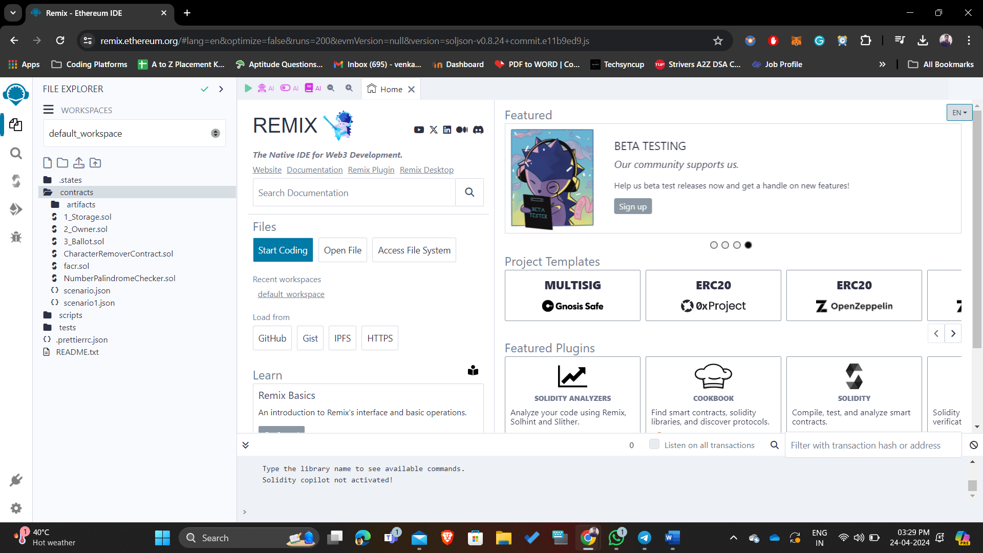

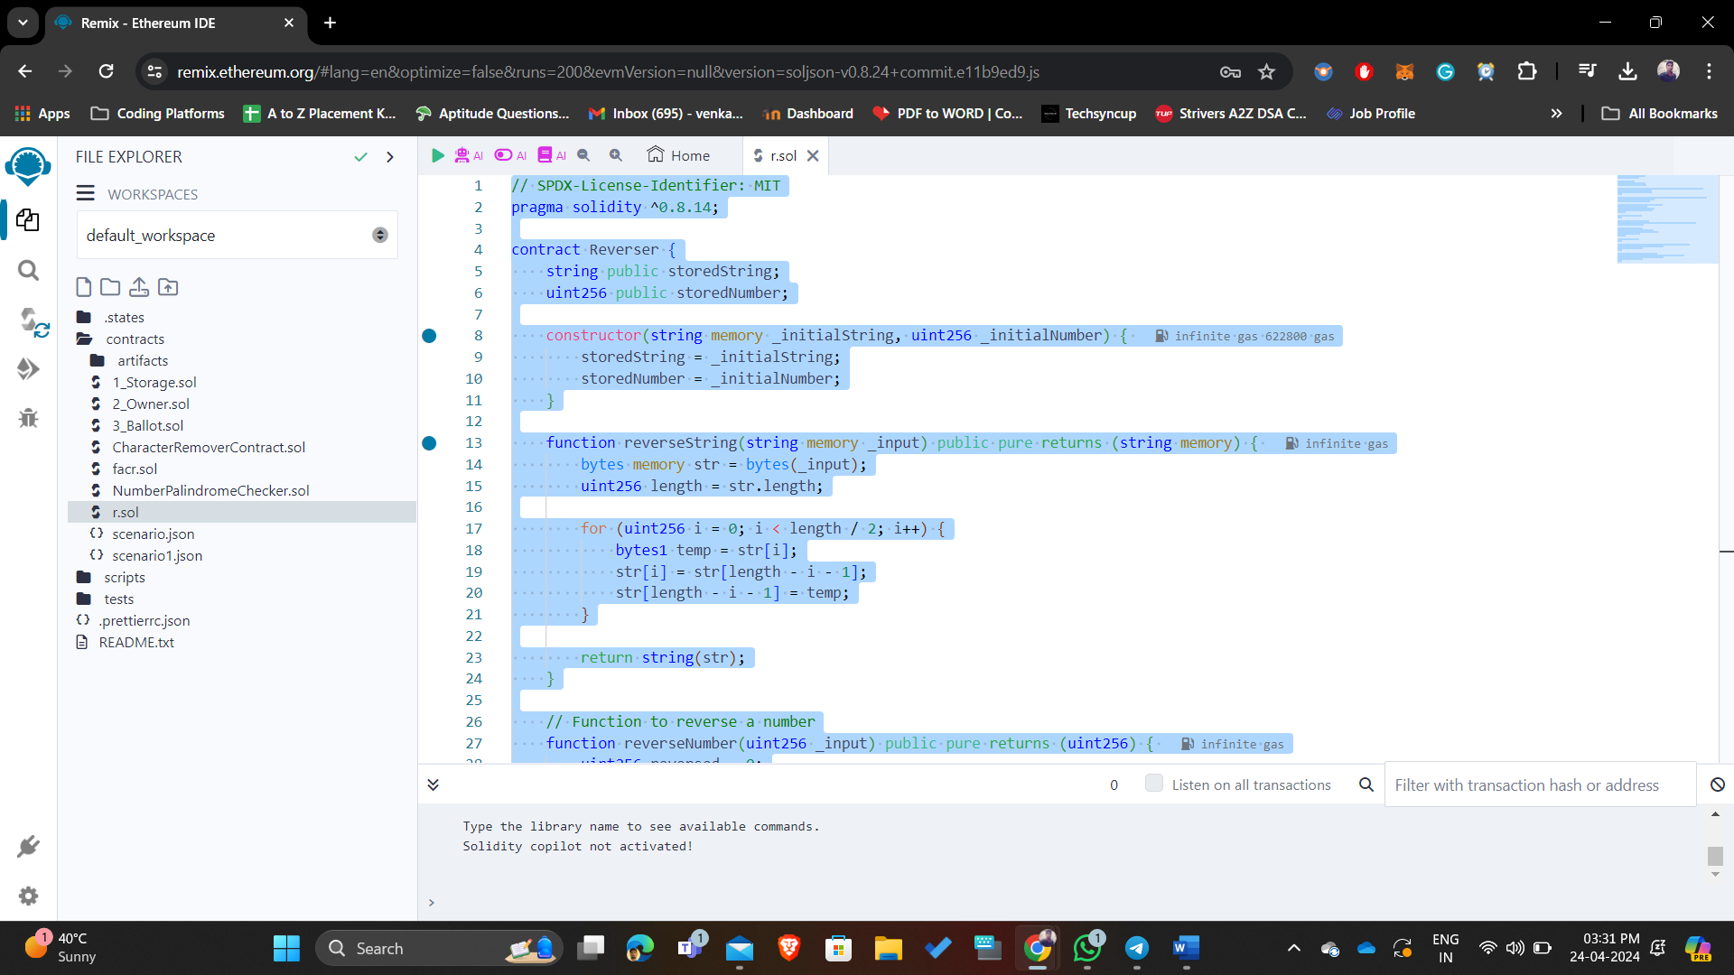

Code

|  |
| --- |
| // SPDX-License-Identifier: MIT  pragma solidity ^0.8.14;  contract Reverser {      string public storedString;      uint256 public storedNumber;      constructor(string memory _initialString, uint256 _initialNumber) {          storedString = _initialString;          storedNumber = _initialNumber;      }      function reverseString(string memory _input) public pure returns (string memory) {          bytes memory str = bytes(_input);          uint256 length = str.length;          for (uint256 i = 0; i < length / 2; i++) {              bytes1 temp = str[i];              str[i] = str[length - i - 1];              str[length - i - 1] = temp;          }          return string(str);      }      // Function to reverse a number      function reverseNumber(uint256 _input) public pure returns (uint256) {          uint256 reversed = 0;          while (_input > 0) {              uint256 digit = _input % 10;              reversed = reversed * 10 + digit;              _input /= 10;          }          return reversed;      }      function reverseStoredString() public returns (string memory) {          storedString = reverseString(storedString);          return storedString;      }      // Function to reverse the stored number      function reverseStoredNumber() public returns (uint256) {          storedNumber = reverseNumber(storedNumber);          return storedNumber;      }  } |



